MOBILE PASS ENROLLMENT USER GUIDE

The enrollment process is the same on Windows desktop or mobile devices
(Android/IOS/BlackBerry)

- For mobile device download SafeNet software from playstore.

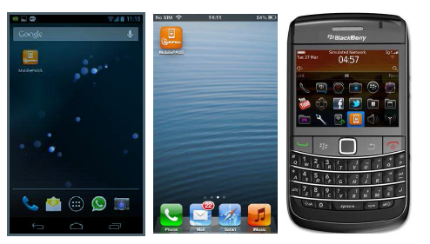

- Go to self-Portal (http://selfportal.capgemini.com) from your device.

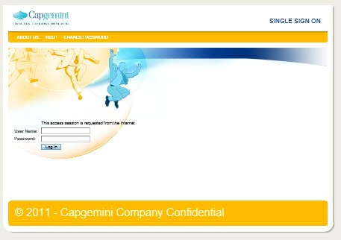

- Provide Capgemini User ID and password.

- Click on Assign Mobile PASS Token in the right menu.

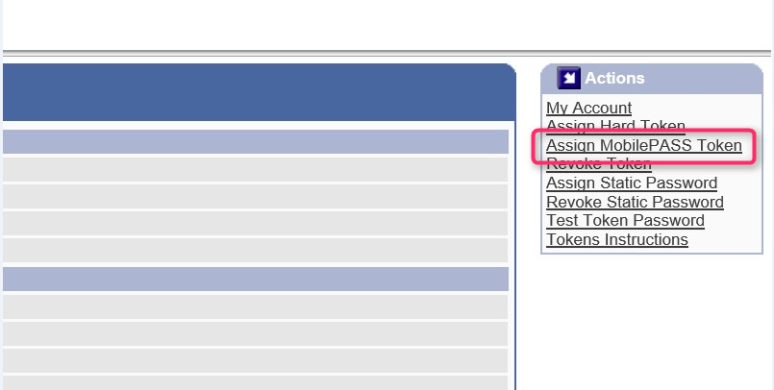

- Enter your joining date of Capgemini and manager last name to validate your identity and then click Save.

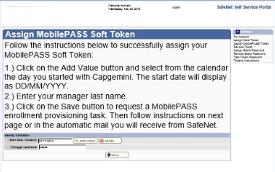

- You are now redirected to the activation page displaying your activation link. Note that you also receive the same link by email in your mailbox.

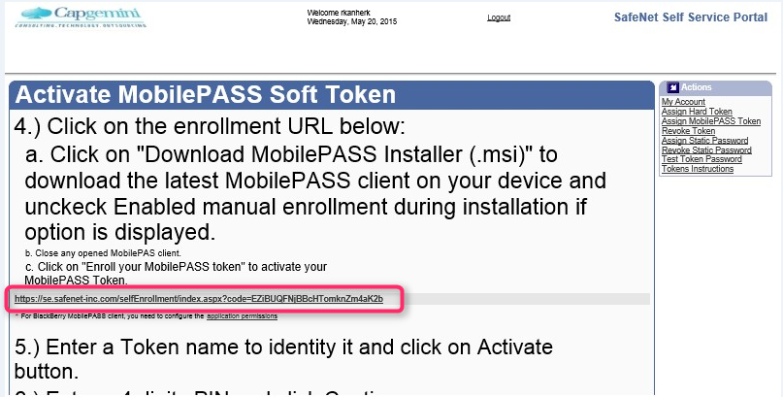

- Click on Activation Link it will redirect you SAS SafeNet Authentication Service Self Enrollment page automatically.

- Click on Enroll Your Mobile PASS token it will redirect you to mobile device SafeNet application automatically.

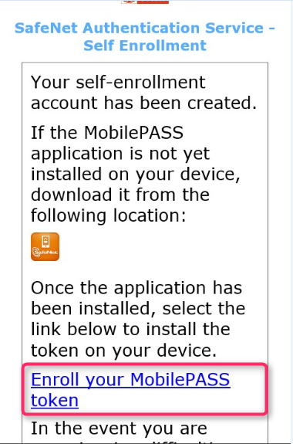

- Press Activate the Auto Enrollment window appears, with the activation string automatically copied and pasted in the display, and the enrollment process begins.

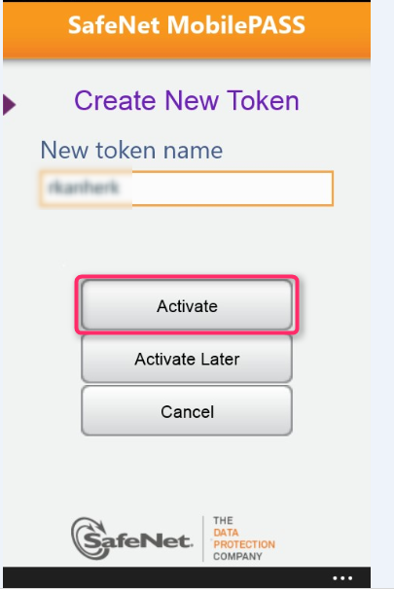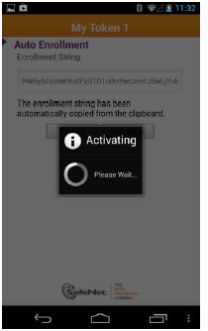

- Enter your PIN code and then confirm it.

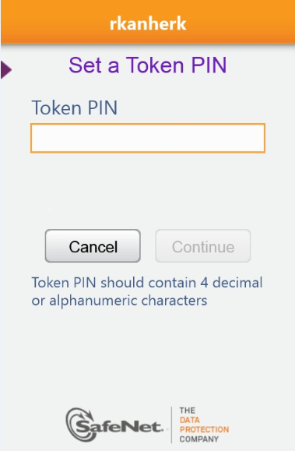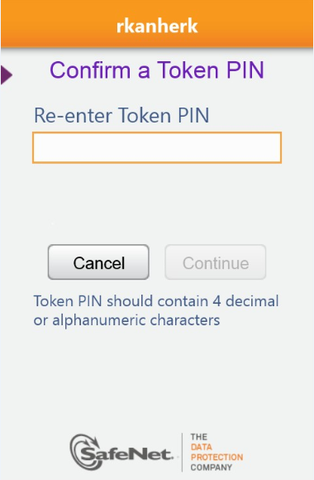

Your Passcode is displayed on your MobilePASS window.

